***Sample analysis plots and dashboards for sample datasets using Tableau***

I have tried to develop some analysis plots and dashboards for Tableau dataset.

1. **Big Lottery Dataset.**
   1. Below is the analysis plot for the Male-Female Ratio vs. Region. The plot interprets, the detailed story about the lottery dataset, for Male-Female Ratio for Region.

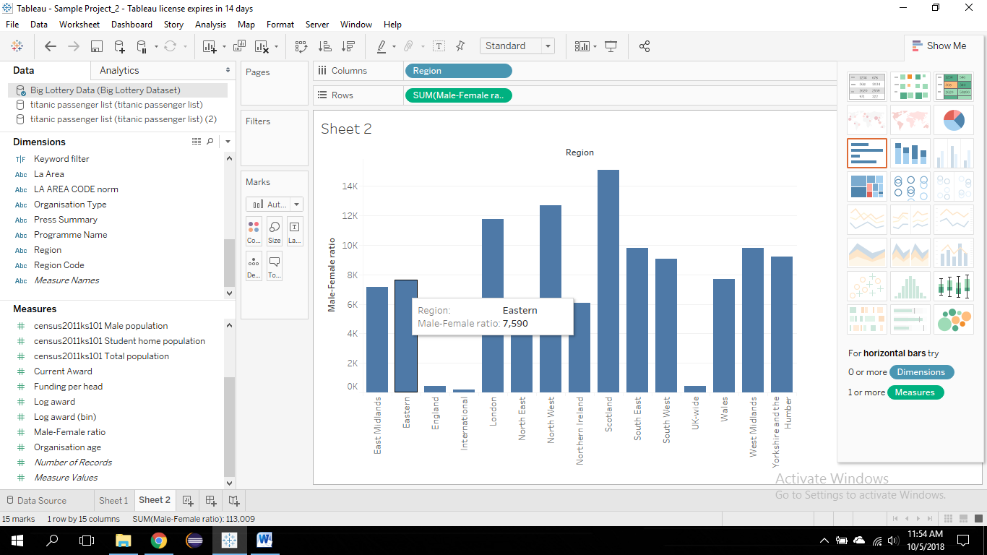

* 1. Below is the analysis plot for the Male-Female Ratio vs. Region, Organisation Type. The plot interprets the detailed story about the lottery dataset for Male-Female Ratio vs. Region, Organisation Type.

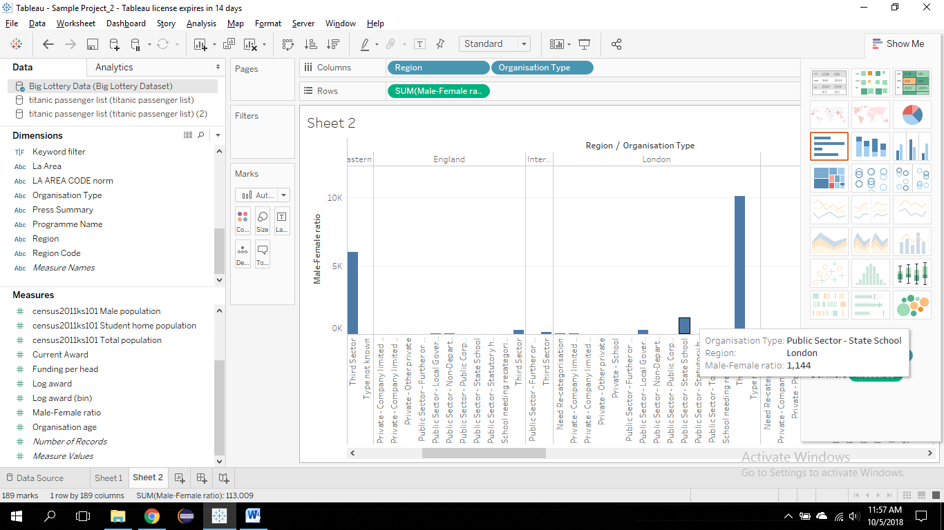

* 1. Dashboard for lottery data for Male-Female Ratio against Region and Organisation Type.

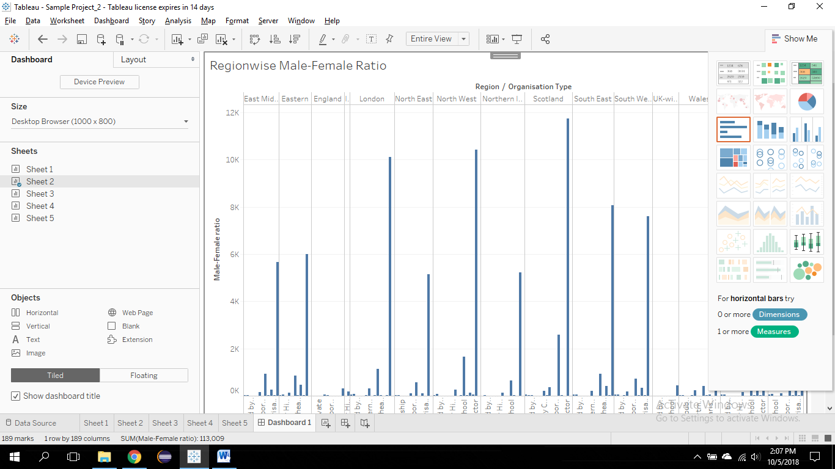

1. **Global Sport Finances Dataset.**
   1. Below is the analysis plot for the league sport team and total payroll. The plot interprets the total payroll of the players for the sport teams.

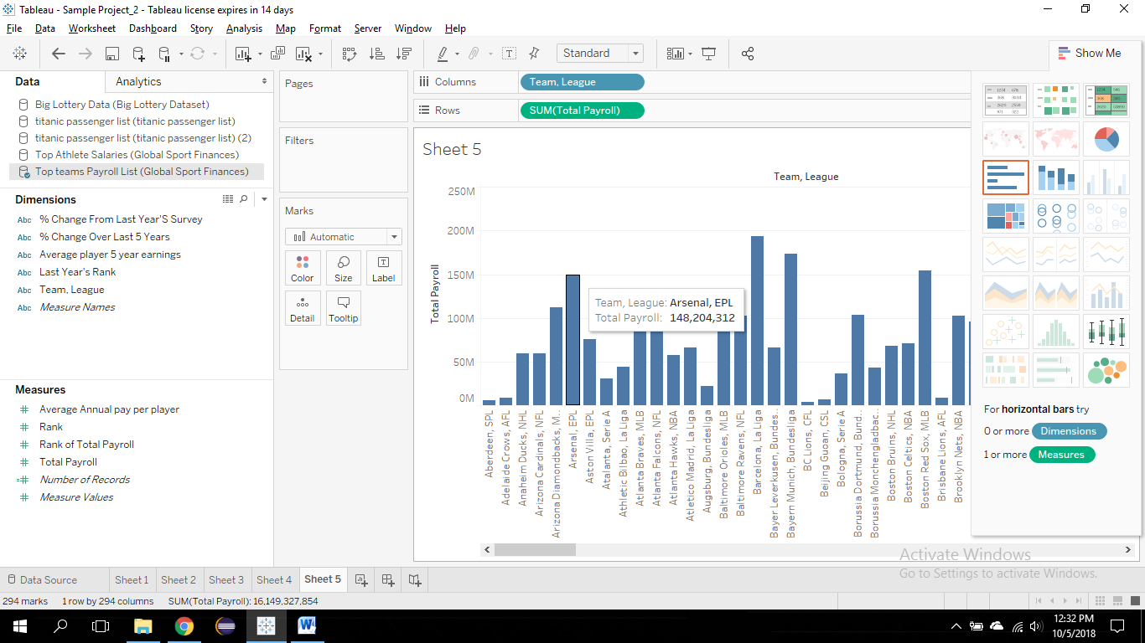

1. **Olympic Medalists dataset.**
   1. Below is the analysis plot for the Medal types and Gender. The pie chart interprets the bronze, gold and silver medalists gender wise.

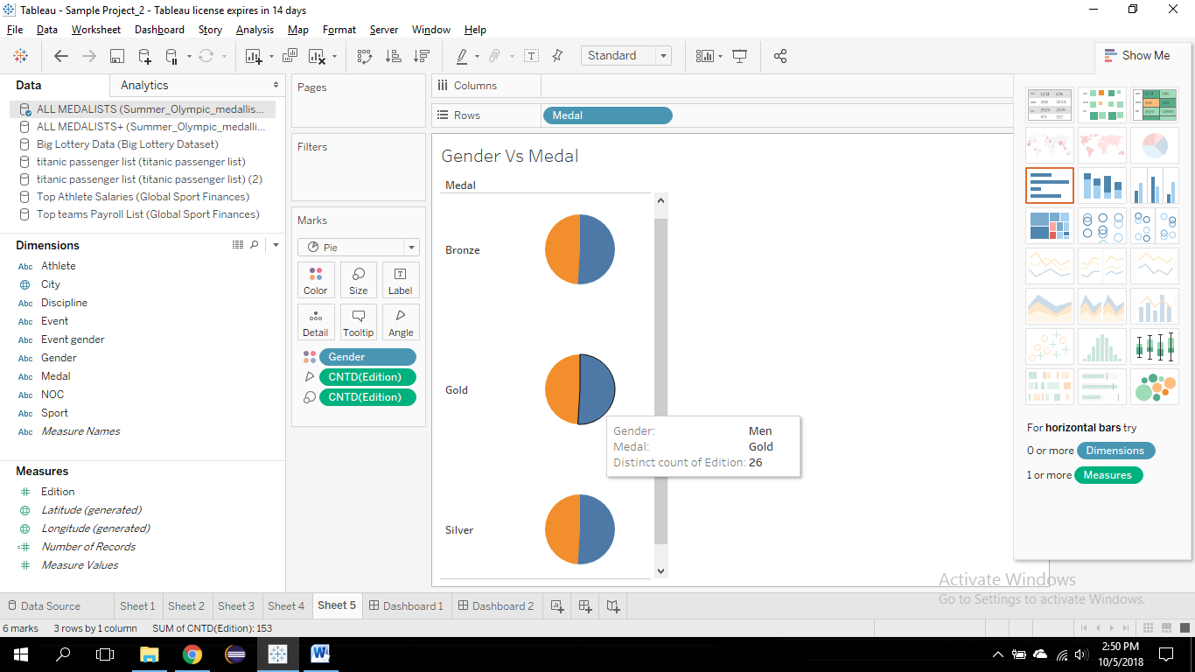

* 1. Below is the analysis plot for the total medals won by the athelete for each country.

